**MIRACLE SAINTS JUNIOR SCHOOL NKUMBA**

**MID TERM II EXAMINATIONS 2024**

**TOP CLASS: (5 – 6 YEARS)**

**LEARNING AREA 5: LANGUAGAE DEVELOPMENT II**

**My name is: ………………………………..………………………….**

**My School is: ……………………………..……….…………………..**

**I am in: ………………………………..…………………………………………..**

1. **Read these sounds.**

s e n e t r z

* 1. p m f i n g

o h

1. **Read and say the syllables.**

ma se po ha ve ta me de za ge no fa ye

1. **Read these words well.**

man get hat ten

yam mat set rat red

**4.Read and draw** a cat and a rat a man and a hat

|  |  |  |
| --- | --- | --- |
| |  | | --- | |  | |  |

* 1. pen and a net a van and a fan

a boy and a girl a book and a pencil

**5.Write phrases for the pictures**

**_____________________**

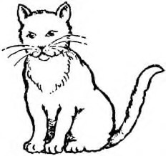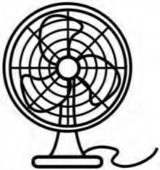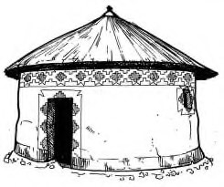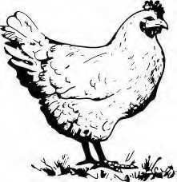

**______________________**

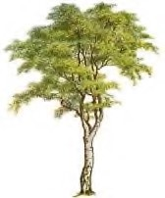

**__________________________________________________**

**_________________________**

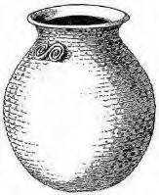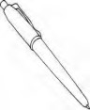

1. **Fill in the missing letter**

t____p y_____m

b____ll

1. **Colour the flower.**

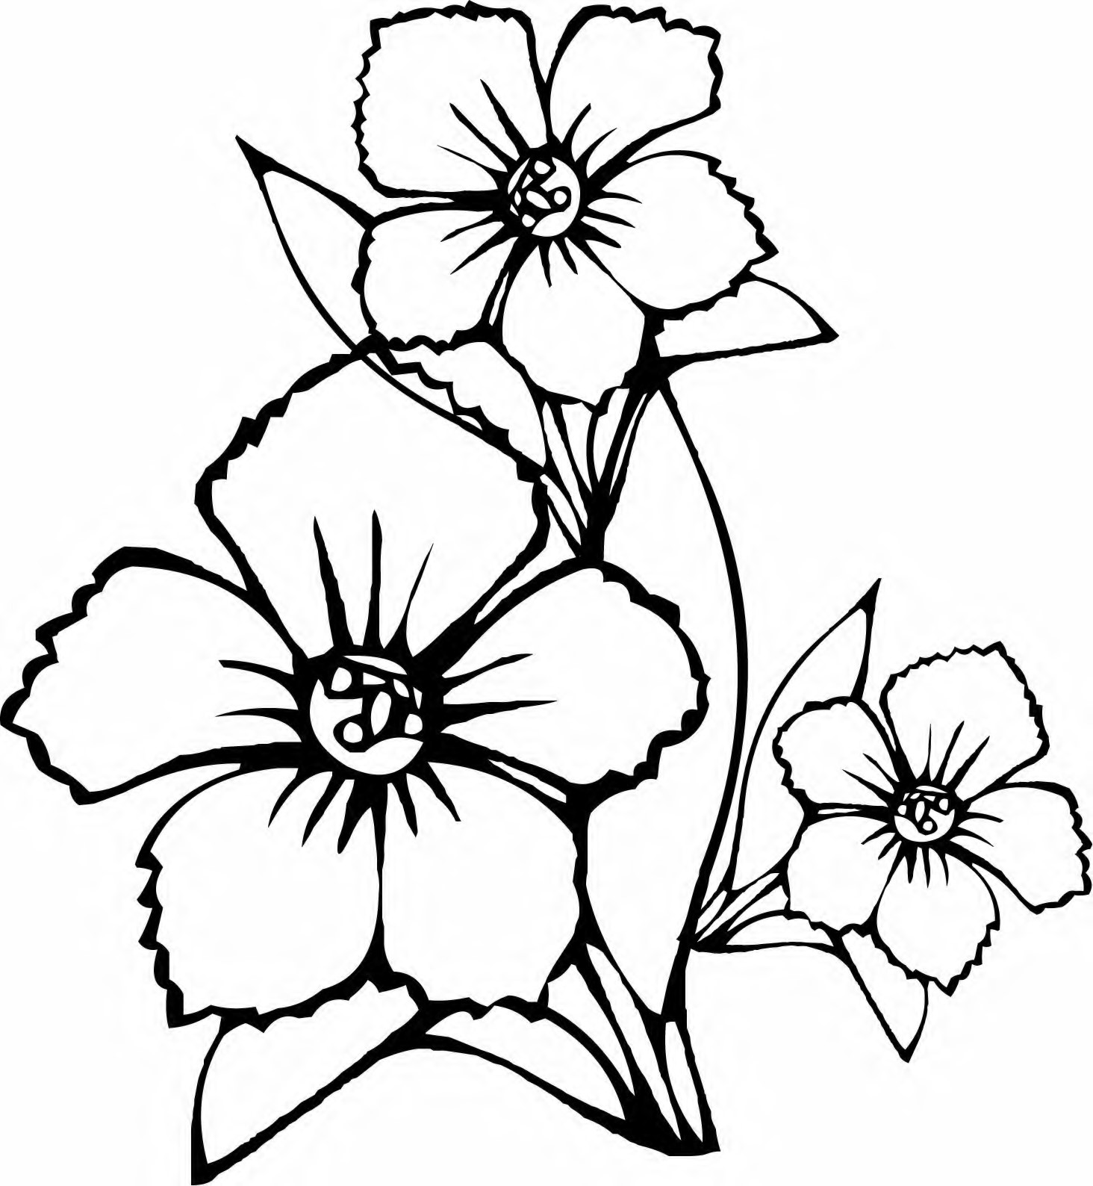

**END**